Gardener F5 Application Load Balancer Extension
Part 4 - Ingress Detailed Design
IngressClass, host/path routing, TLS, grouping, deployment, status and lifecycle
Version 1.0 | July 2026

Document Purpose and Scope
This part defines the implementation design for translating Kubernetes networking.k8s.io/v1 Ingress resources into CMP-managed F5 application load-balancer resources. It continues the controller, desired-state, ownership, deployment-manager and typed-client architecture established in Parts 1 and 2. Service backend resolution reuses the backend model described in Part 3, while this part adds class selection, grouping, host/path routing, default backends, TLS certificates and shared frontend lifecycle.
Critical resource-model rule
Ingress does not bypass the CMP LB Service. The complete managed graph is: Ingress group -> LB Service -> VIP -> HTTP/HTTPS Virtual Servers -> routing rules -> pools -> members, with certificates attached to HTTPS Virtual Servers.

Design Scope
- IngressClass and controller ownership
- Single and grouped Ingress reconciliation
- Exact, Prefix and implementation-specific path handling
- Host, wildcard-host and hostless rules
- Default backend behavior
- HTTP and HTTPS listeners
- TLS Secret validation and CMP certificate lifecycle
- Routing-rule ordering and deterministic priority
- Pool and backend generation from referenced Services
- Ingress status, conditions and events
- Unsupported and ambiguous configurations
- Group-aware update and deletion
- Sequence, state and resource diagrams

Table of Contents
4.1 Design Objectives
4.2 Ingress Reconciliation Overview
4.3 IngressClass Handling
4.4 Ingress Object Analysis
4.5 Validation
4.6 Grouping and Shared Frontends
4.7 Host and Path Routing
4.8 Default Backend
4.9 TLS and Certificates
4.10 Backend Services, Pools and Members
4.11 Desired-State Generation
4.12 CMP/F5 Resource Mapping
4.13 Deployment Algorithm
4.14 Status and Conditions
4.15 Failure Recovery
4.16 Delete and Group-Change Flow
4.17 Unsupported and Deferred Cases
4.18 Sequence Diagrams
4.19 Design Decisions
4.20 Implementation Checklist

4.1 Design Objectives

4.1.1 Kubernetes Semantics to Preserve
Ingress semantic | Required behavior
IngressClass ownership | Only classes whose spec.controller matches this extension are reconciled.
Host routing | Requests are routed using the HTTP Host header or TLS SNI-associated host configuration.
Path routing | More specific matches take precedence; Exact and Prefix semantics remain deterministic.
Default backend | Used only when no host/path rule matches, or as the only backend on a rule-less Ingress.
TLS | Secrets referenced by spec.tls are resolved and attached to HTTPS listeners for the declared hosts.
Status | status.loadBalancer reflects the reachable VIP only after successful verification.
Deletion | Finalizers protect provider cleanup, including shared-group membership changes.

4.1.2 Extension Guarantees
- A full Ingress group is reconciled as one desired-state stack.
- Stable LB Service, VIP and listeners are preserved when only rules, certificates or backends change.
- Rule ordering is deterministic and independent of Kubernetes list/watch event order.
- Referenced Services and Service ports are resolved before provider mutation.
- Conflicting group members are rejected rather than merged unpredictably.
- Certificates are never logged; Secret data is handled only in memory and provider transport.
- Owned provider resources are discovered and reconciled after restart.
- A deleted member of a shared group removes only its contribution unless the group becomes empty.

4.1.3 Non-goals
- Gateway API support; it requires a separate design.
- TCP/UDP routing through an HTTP Ingress.
- Arbitrary F5 policy scripting or provider-specific expressions supplied directly by users.
- Cross-namespace backend references unless a future explicit authorization model is introduced.
- Silent approximation of unsupported path or TLS behavior.

4.2 Ingress Reconciliation Overview
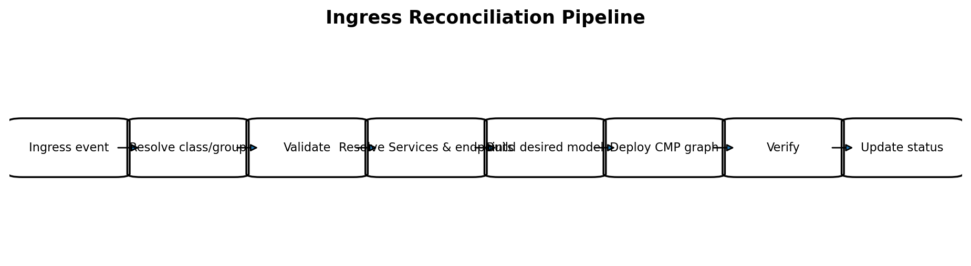
Figure 4-1. End-to-end Ingress reconciliation pipeline.
The reconciliation unit is an Ingress group, not necessarily one Ingress object. A class resolver first decides whether the object belongs to this controller. A group resolver then determines all objects that share one frontend. The model builder receives an immutable snapshot of the complete group and produces one desired IngressStack.

4.2.1 Watch Sources
Watched resource | Why it enqueues reconciliation
Ingress | Rules, hosts, TLS, annotations, class or deletion changed.
IngressClass | Controller ownership or parameter defaults changed.
Service | Referenced backend port or eligibility changed.
EndpointSlice | Backend membership or readiness changed.
Secret | Referenced certificate or private key changed.
Node | Node-based backend resolution changed.
Optional parameter CRD/ConfigMap | Class/group defaults or CMP policy changed.

4.2.2 Thin Controller Contract
Reconcile(Ingress key):
fetch latest Ingress
resolve IngressClass and group key
list all current group members
read referenced Services, EndpointSlices, Secrets and Nodes
validate immutable input snapshot
desired = groupModelBuilder.Build(snapshot)
result = ingressStackDeployer.Deploy(desired)
statusWriter.Publish(group members, result)

4.3 IngressClass Handling
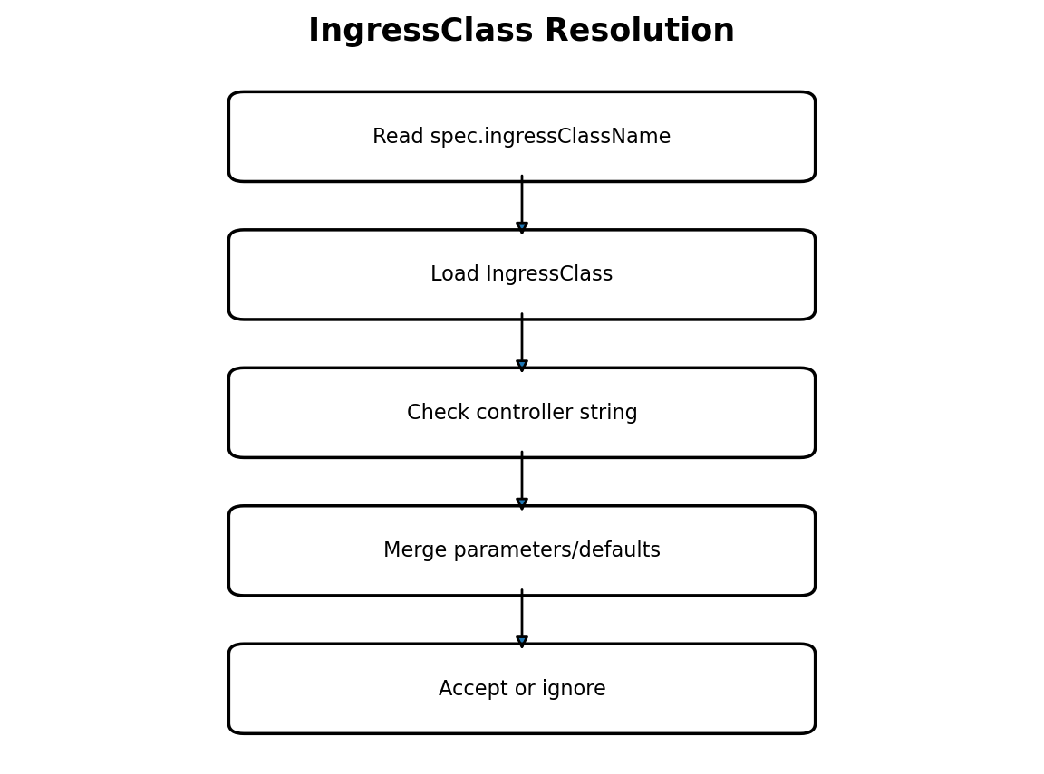
Figure 4-2. IngressClass resolution and ownership.

4.3.1 Controller Identifier
The extension defines one stable controller identifier, for example networking.f5.cmp/ingress-controller. An IngressClass is managed only when spec.controller exactly equals this value. The identifier is a compatibility contract and must not be changed casually after release.

4.3.2 Class Selection Rules
Ingress configuration | Decision
spec.ingressClassName names a matching class | Accept.
spec.ingressClassName names a class owned by another controller | Ignore without finalizer or provider mutation.
spec.ingressClassName names a missing class | Reject with ResolvedRefs=False and event.
No class name and exactly one configured default matching class | Accept.
No class name and no default | Ignore or reject according to deployment policy; default recommendation is ignore.
Legacy kubernetes.io/ingress.class annotation only | Optional migration support; disabled by default in new deployments.
Class parameters invalid or inaccessible | Reject before desired-state generation.

4.3.3 IngressClass Parameters
Class parameters should hold shared defaults rather than per-application routing intent. Recommended fields include CMP project/tenant reference, network/subnet, default visibility, default health-monitor policy, certificate policy, permitted annotations and group policy. Per-Ingress values may override only fields explicitly declared overrideable.
Precedence
Controller configuration < IngressClass parameters < approved Ingress annotations. Security-sensitive values such as CMP tenant identity and ownership prefix are not overrideable by application namespaces.

4.4 Ingress Object Analysis
Field | Used | Mapping / rule
spec.ingressClassName | Yes | Controller ownership and defaults.
spec.defaultBackend | Yes | Fallback pool or sole pool for a rule-less Ingress.
spec.rules[].host | Yes | Host match predicate; empty means all hosts.
spec.rules[].http.paths[] | Yes | Routing rules and backend pools.
pathType | Yes | Exact, Prefix or explicitly supported ImplementationSpecific behavior.
backend.service.name | Yes | Same-namespace Service lookup.
backend.service.port | Yes | Resolve by name or number to one ServicePort.
spec.tls[].hosts | Yes | Certificate host coverage and listener binding.
spec.tls[].secretName | Yes | TLS certificate and private key input.
metadata.annotations | Yes, allowlisted | Grouping and approved CMP options.
status.loadBalancer | Output only | Never used as provider source of truth.

4.4.1 Backend Service Port Resolution
- Fetch the referenced Service in the Ingress namespace.
- If the backend port is a name, require exactly one ServicePort with the same name.
- If it is a number, match ServicePort.port, not targetPort.
- Reject missing or ambiguous matches.
- Pass the resolved ServicePort and EndpointSlices to the shared backend resolver from Part 3.

4.4.2 Snapshot Consistency
The model builder receives resource identities and resourceVersions for all inputs. It does not re-read the API server. If a referenced object changes during deployment, its watch event enqueues a new reconcile; convergence remains eventually consistent and deterministic.

4.5 Validation
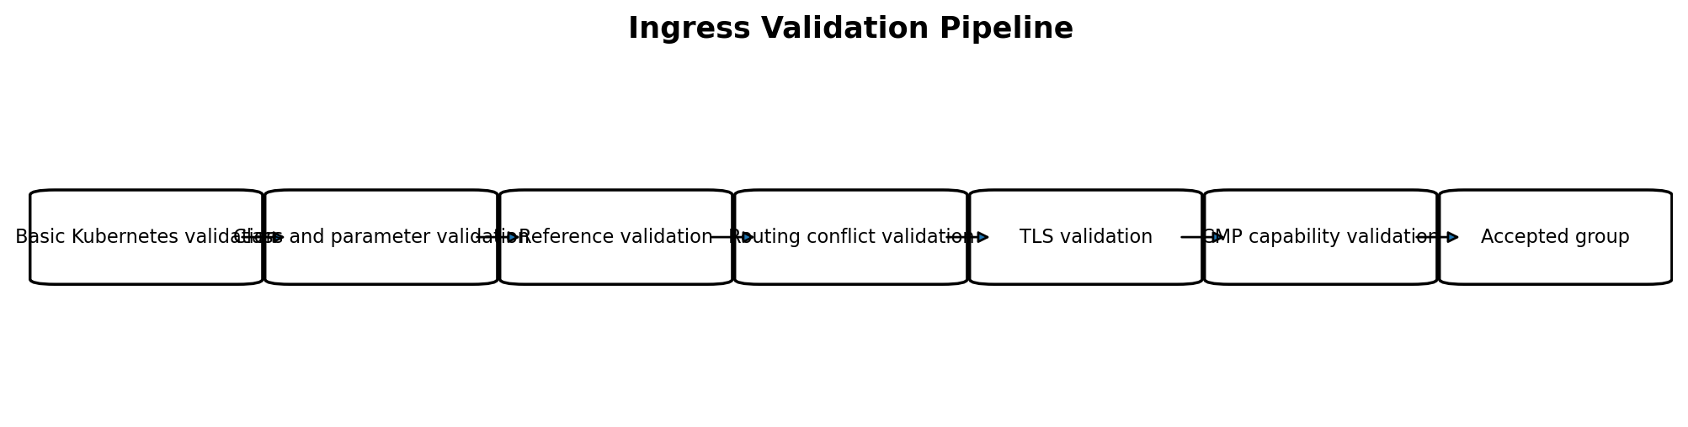
Figure 4-3. Validation stages before provider mutation.
Validation category | Examples
Basic | At least one rule or default backend; syntactically valid hosts; non-empty path where required.
Class | Matching controller; valid parameters; allowed annotations.
References | Services, ports and TLS Secrets exist and are in the permitted namespace.
Routing conflicts | No duplicate host/path with incompatible backends; no ambiguous group listener policy.
TLS | Secret type/content valid; key matches certificate; certificate covers declared hosts according to policy.
CMP capability | Requested listener, routing predicate, persistence, redirect and certificate behavior can be represented.
Quota/limits | Number of rules, pools, certificates and members within configured/CMP limits.

4.5.1 Admission Webhook versus Reconcile Validation
Webhook | Reconcile
Fast static validation of fields, annotations and class references. | Authoritative runtime validation of Services, Secrets, EndpointSlices and CMP capability.
Rejects obvious invalid configurations before persistence. | Handles drift, deletion and references that change after admission.
Must not depend on slow CMP operations. | May use cached CMP capability/configuration information.

Safety rule
No create, update or delete operation is sent to CMP when validation of the complete group fails. Existing healthy resources may be retained while status reports the rejected new desired state.

4.6 Grouping and Shared Frontends
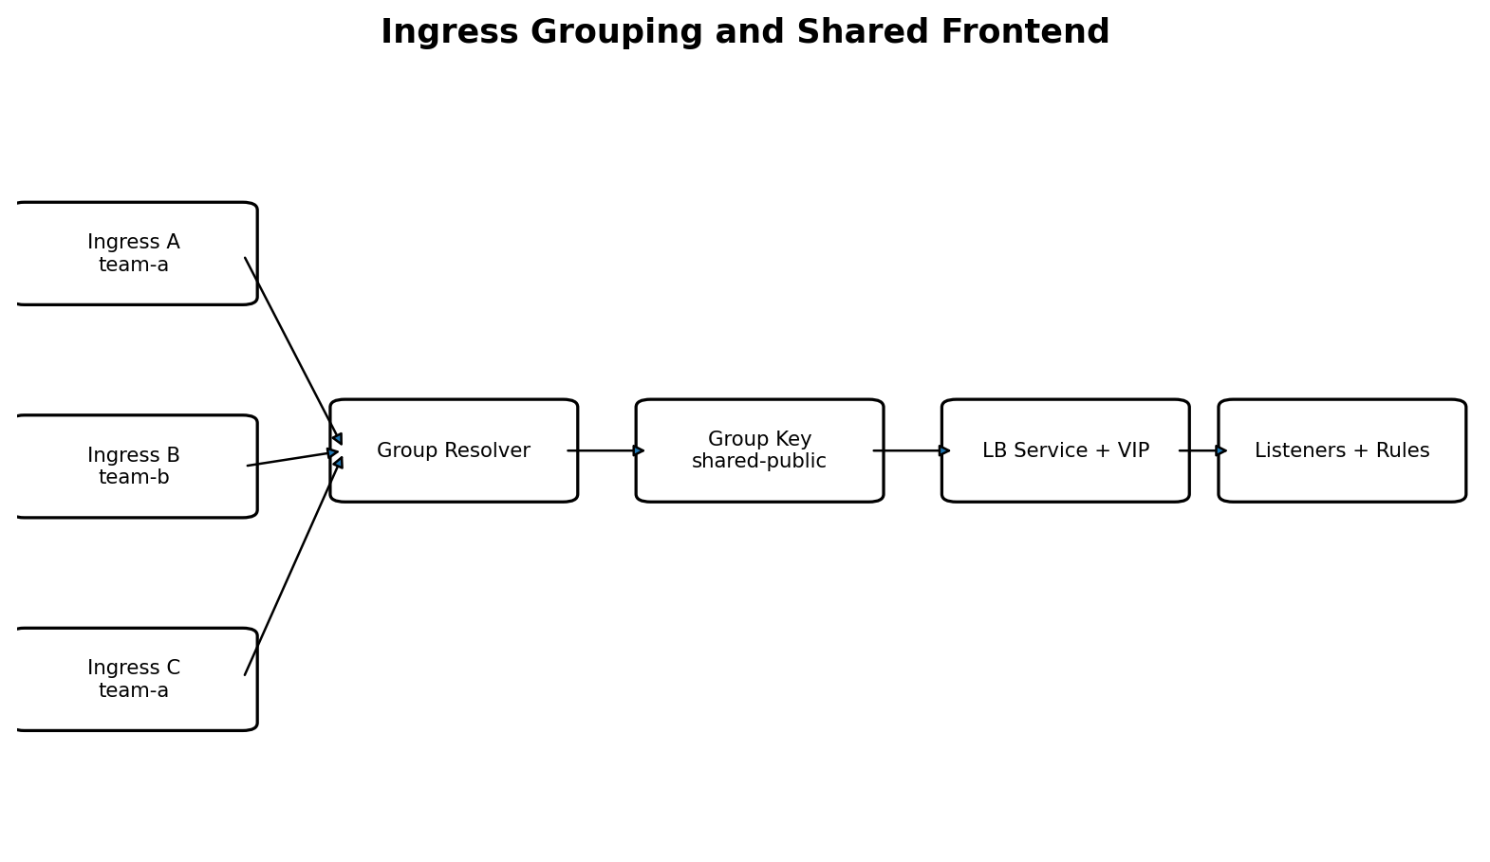
Figure 4-4. Multiple Ingresses sharing one LB Service, VIP and listener set.

4.6.1 Why Grouping Exists
Grouping allows multiple Ingress objects to share one externally reachable VIP while contributing independent host/path rules. It reduces frontend resource consumption but creates a larger ownership and conflict domain. Grouping is therefore explicit, validated and deterministic.

4.6.2 Group Key
GroupKey = {
clusterIdentity,
className,
scope, // namespace or cluster, according to policy
explicitGroupName, // annotation/parameter; absent => implicit single-object group
networkProfile,
visibility,
listenerProfile
}
An Ingress without an explicit group name forms an implicit group keyed by its UID. It never accidentally shares a frontend merely because another Ingress uses the same host.

4.6.3 Group Merge Rules
Property | Merge rule
Hosts and paths | Union after conflict validation.
HTTP/HTTPS listener ports | Must agree across members or use class defaults.
Visibility/network | Must be identical.
TLS certificates | Union by certificate fingerprint/Secret identity; duplicate data de-duplicated.
Default backend | At most one effective default backend per group.
Annotations affecting shared frontend | Must match; conflicts reject the group.
Annotations affecting only one route/pool | Applied to the contributing route/pool.
Ownership | Group frontend owned by group key; child routes additionally record source Ingress UID.

4.6.4 Security Boundaries
- Namespace-local grouping is the safe default.
- Cluster-wide groups require explicit administrator enablement.
- Cross-namespace members cannot override shared security-sensitive settings.
- An object may contribute only backends and Secrets it is authorized to reference.
- Group membership and conflicts are visible through Events and Conditions on every member.

4.7 Host and Path Routing
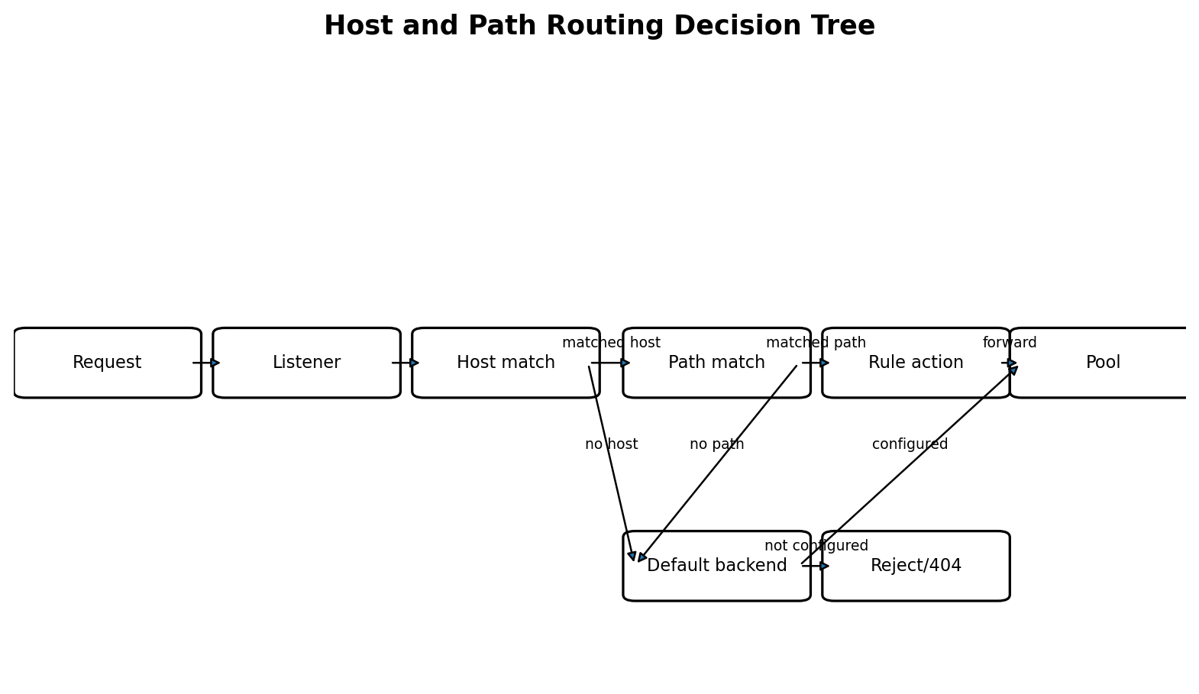
Figure 4-5. Runtime host/path selection and fallback behavior.

4.7.1 Host Matching
Host form | Behavior
Exact host: api.example.com | Match normalized host without port, case-insensitively.
Wildcard host: *.example.com | Match exactly one DNS label before example.com; do not match example.com or a.b.example.com.
Empty host | Catch-all host predicate for the listener; ordered after explicit hosts.
Duplicate host from multiple members | Allowed only when paths are non-conflicting and shared listener policy matches.

4.7.2 Path Matching
pathType | Desired rule behavior
Exact | Match the complete normalized request path exactly.
Prefix | Match by path-element prefix semantics. /foo matches /foo and /foo/bar, but not /foobar.
ImplementationSpecific | Rejected by default. Enable only when a documented CMP/F5-compatible interpretation is selected in class policy.

4.7.3 Deterministic Rule Ordering
The model builder assigns stable priority using semantic specificity rather than list order. The recommended ordering is: exact host before wildcard host before hostless; Exact path before Prefix path; longer path before shorter path; stable lexical and source-UID tie-breakers only after semantic specificity.
sortKey(rule) = (
hostClassRank, // exact < wildcard < catch-all
-hostLabelCount,
pathTypeRank, // Exact < Prefix
-normalizedPathLength,
normalizedHost,
normalizedPath,
sourceIngressUID
)

4.7.4 Rule Actions
- Primary supported action: forward to one pool.
- Optional HTTP-to-HTTPS redirect is represented as a listener/default action only when CMP supports it explicitly.
- No arbitrary user-provided provider expression is accepted.
- A rule references a logical pool ID; deployment managers resolve the physical CMP ID.

4.8 Default Backend

4.8.1 Semantics
The default backend handles requests that do not match any host/path rule. A rule-less Ingress with spec.defaultBackend creates a frontend whose default action forwards to that pool. In a grouped frontend, at most one effective default backend may exist.
Situation | Result
One group member defines defaultBackend | Use it as listener fallback.
Multiple members define the same backend | De-duplicate and accept.
Multiple members define different defaults | Reject group as conflicting.
No default backend | Use a controlled provider response such as 404/reject when supported; otherwise create no catch-all forwarding rule.
Default Service/port missing | Set ResolvedRefs=False; do not deploy the invalid desired change.

4.8.2 Separation from Catch-all Host Rules
A hostless rule with paths is not identical to defaultBackend. Hostless paths still participate in ordered path matching. The default backend is evaluated only after all route rules fail.

4.9 TLS and Certificates
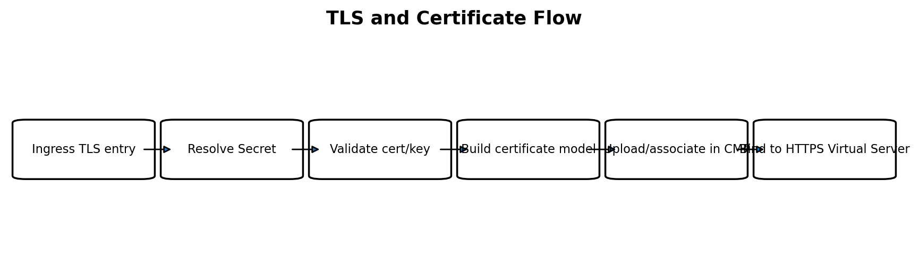
Figure 4-6. TLS Secret resolution and CMP certificate association.

4.9.1 Secret Requirements
Requirement | Validation
Namespace | Secret must be in the same namespace as the contributing Ingress unless a future reference-grant model exists.
Data keys | tls.crt and tls.key must be present.
Certificate parse | PEM chain parses; leaf certificate identified.
Private key parse | Supported key type and encoding.
Key match | Public key in leaf certificate matches private key.
Validity | Warn or reject expired/not-yet-valid certificates according to class policy.
Host coverage | Declared TLS hosts are covered by SAN/CN according to configured enforcement policy.
Size/count | Within CMP and controller limits.

4.9.2 Certificate Desired Model
CertificateModel {
LogicalID
SourceSecret {namespace, name, uid, resourceVersion}
FingerprintSHA256
PEMCertificateChain
PEMPrivateKey // sensitive, never serialized to logs/status
Hosts[]
Ownership
}

4.9.3 De-duplication and Rotation
- Certificates with the same fingerprint may be uploaded once and referenced by multiple listeners when CMP permits.
- A Secret resourceVersion change rebuilds the certificate model.
- Rotation creates or updates the provider certificate before changing listener bindings.
- The old certificate is deleted only after no desired listener references it.
- Sensitive values are redacted from errors and structured logs.

4.9.4 SNI and Listener Model
One HTTPS Virtual Server may reference multiple certificates when CMP/F5 supports SNI certificate selection. If the CMP API supports only one certificate per Virtual Server, the capability validator must either require one compatible certificate for the group or generate separate HTTPS Virtual Servers per certificate/host set. The selected strategy is a platform capability, not an ad-hoc controller decision.

4.10 Backend Services, Pools and Members
Each unique backend Service and resolved ServicePort normally maps to one logical pool within the Ingress group. Multiple routing rules may reference the same pool. Pool identity is independent of host/path so route changes do not churn backend resources.
PoolLogicalID = hash(
groupKey,
serviceNamespace,
serviceUID,
servicePortIdentity,
backendMode,
healthMonitorPolicy
)

4.10.1 Backend Resolution
- Resolve the ServicePort referenced by the Ingress backend.
- Read EndpointSlices owned by the Service.
- Filter endpoints according to readiness and termination policy.
- Resolve each endpoint to a Node when node/NodePort backend mode is used.
- Resolve Node -> CMP VM -> network port -> backend_port_id.
- Use the Service NodePort associated with the resolved ServicePort.
- Build deterministic, de-duplicated pool members.

4.10.2 Empty Backends
State | Behavior
Service exists, zero ready endpoints | Keep pool with zero active members when CMP supports it; listener remains but backend is unavailable.
Service missing | Reference error; reject desired update.
Port missing | Reference error; reject desired update.
Some endpoints fail provider resolution | Default policy rejects the pool to avoid silent partial routing; optional degraded policy must be explicit.
Endpoint becomes unready | Remove or disable member according to deployment policy.

4.10.3 Health Monitors
Monitor policy is derived from class defaults plus approved route/pool annotations. Identical monitor configurations may be shared if CMP supports sharing; otherwise each pool owns a monitor. Monitor path, interval, timeout, expected status and protocol must be validated against the backend protocol.

4.11 Desired-State Generation

4.11.1 Input Snapshot
IngressGroupBuildInput {
GroupKey
Ingresses[]
IngressClass
ClassParameters
Services map[ObjectKey]Service
EndpointSlices map[ServiceKey][]EndpointSlice
Secrets map[ObjectKey]Secret
Nodes map[string]Node
ResolvedProviderBackends
CapabilityProfile
}

4.11.2 Output Stack
IngressStack
LBService
VIP
VirtualServers[] // HTTP and/or HTTPS listeners
RoutingRules[]
Pools[]
PoolMembers[]
HealthMonitors[]
Certificates[]
SourceIndex // source Ingress UID -> contributed logical IDs
OwnershipMetadata
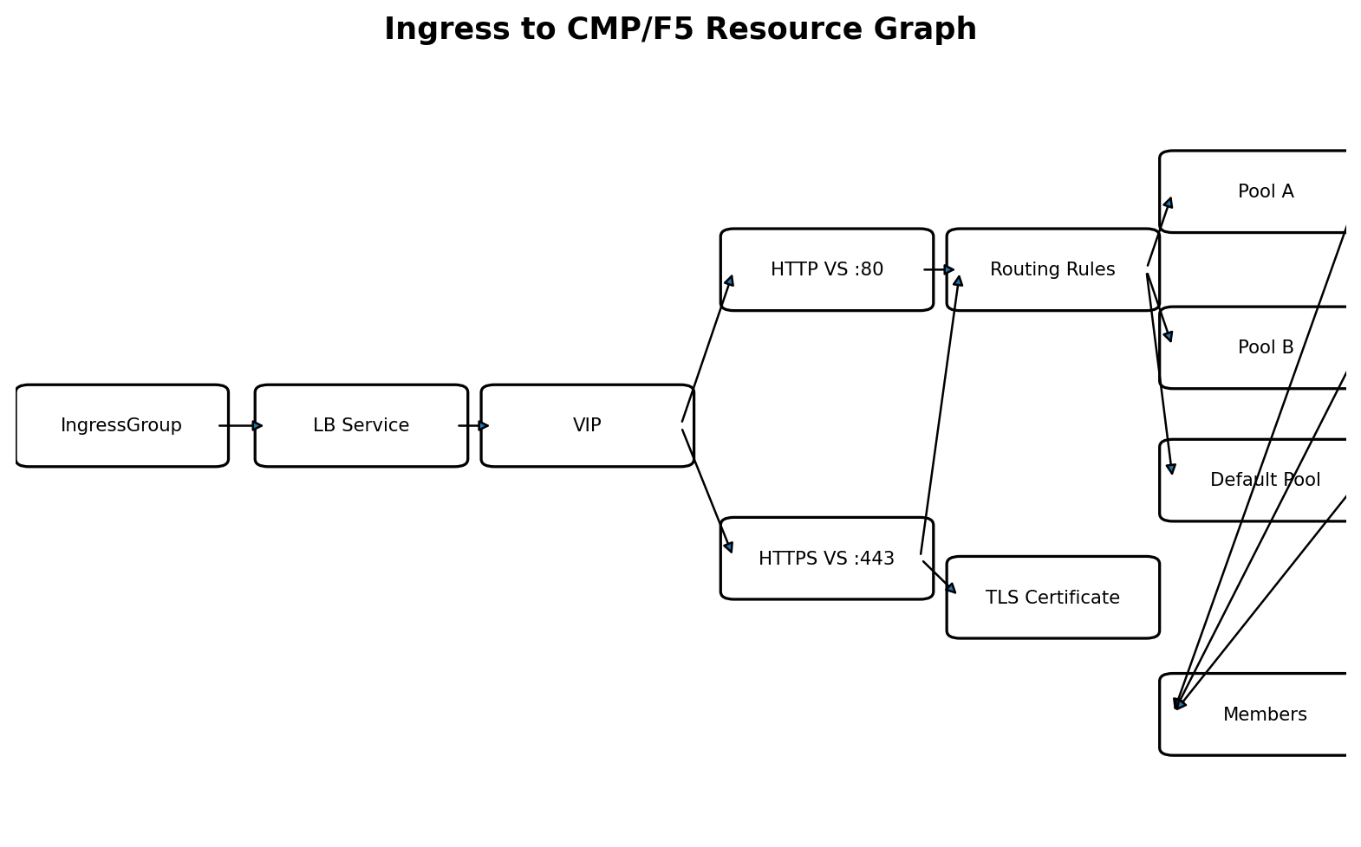
Figure 4-7. Complete Ingress resource graph. The CMP LB Service remains the top-level provider resource.

4.11.3 Builder Stages
- Normalize and sort group members.
- Merge class parameters and approved annotations.
- Build shared LB Service and VIP models.
- Determine listener set and TLS strategy.
- Resolve and de-duplicate backend pools.
- Build certificates and listener associations.
- Build host/path rules with stable priority.
- Build default actions.
- Attach ownership and source-contribution metadata.
- Validate graph invariants before returning the stack.

4.11.4 Graph Invariants
- Every routing rule references an existing Virtual Server and Pool.
- Every pool has a stable logical ID and zero or more members.
- Every HTTPS listener satisfies the configured certificate policy.
- Every physical resource has group ownership metadata.
- Every route-specific child records its source Ingress UID.
- No two desired rules have an ambiguous equal match and incompatible action.

4.12 CMP/F5 Resource Mapping
Kubernetes concept | Internal model | CMP/F5 resource
Ingress group | IngressStack root | LB Service
External address | VIP model | VIP
HTTP listener | VirtualServer model | Virtual Server on port 80
HTTPS listener | VirtualServer model | Virtual Server on port 443
Host/path entry | RoutingRule model | Routing Rule / policy rule
Backend Service+port | Pool model | Pool
Resolved endpoint | PoolMember model | Pool member with backend_port_id and NodePort
Backend health policy | HealthMonitor model | Health monitor
TLS Secret | Certificate model | Certificate associated with HTTPS Virtual Server
Default backend | Listener default action | Default pool/action

4.12.1 Example Mapping
Ingress: shop
host: shop.example.com
/api -> service api:8080
/ -> service web:80
tls secret: shop-tls
CMP graph:
LB Service: k8s-<cluster>-<group>
VIP: allocated/shared address
HTTPS Virtual Server :443 [certificate shop-tls]
rule host=shop.example.com path=/api prefix -> pool api-8080
rule host=shop.example.com path=/ prefix -> pool web-80
default action -> reject/404 (unless defaultBackend configured)
Pools
api-8080 -> node members on api NodePort
web-80 -> node members on web NodePort

4.13 Deployment Algorithm
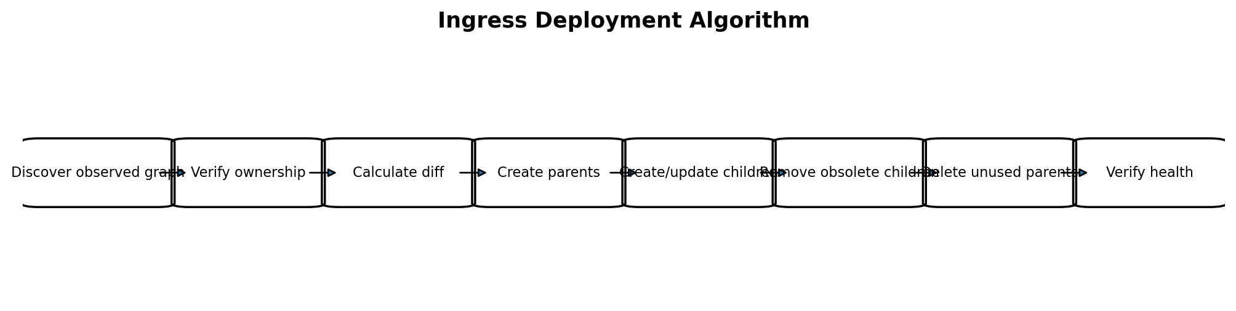
Figure 4-8. Dependency-aware desired-versus-observed deployment.

4.13.1 Dependency Order
Create/update order | Delete order
1. LB Service | 1. Obsolete routing rules
2. VIP | 2. Unreferenced certificates/monitors when safe
3. Certificates and health monitors | 3. Obsolete pool members
4. Pools and members | 4. Obsolete pools
5. Virtual Servers | 5. Obsolete Virtual Servers
6. Routing rules and default actions | 6. VIP
7. Verify complete graph | 7. LB Service

4.13.2 Observed-State Matching
Deployment managers discover resources by ownership metadata and then match desired logical IDs to provider IDs. Name equality alone is insufficient. Resources with matching names but foreign ownership are conflicts, not adoption candidates.

4.13.3 Minimal Mutation
- Rule-only change updates routing rules without recreating VIP/listeners.
- Endpoint change updates members without recreating pools or rules.
- Secret rotation updates certificate binding without changing VIP.
- Adding an Ingress to a group adds only its unique rules, pools and certificates.
- Removing a group member deletes its unreferenced children while retaining shared parents.

4.13.4 Verification
Verification | Success criterion
LB Service/VIP | Exist, owned and provider reports usable state.
Virtual Servers | Configured on intended ports and associated with correct VIP.
Routing rules | All desired logical rules mapped and active.
Pools | Exist and referenced by correct rules.
Members | Observed membership equals desired membership, subject to documented provider normalization.
Certificates | Uploaded and bound to intended HTTPS listeners.
Health | Provider health API has no terminal provisioning error.

4.14 Status and Conditions

4.14.1 Ingress Status
After the group frontend is verified, every member Ingress receives the same external VIP in status.loadBalancer.ingress. The controller does not publish a speculative address before the provider confirms the frontend.
status:
loadBalancer:
ingress:
- ip: <verified-vip>

4.14.2 Recommended Conditions
Condition | Meaning
Accepted | Class, grouping and policy allow this Ingress.
ResolvedRefs | Services, ServicePorts and Secrets resolve successfully.
Programmed | Desired provider graph has been applied and verified.
Ready | Frontend is operational according to configured readiness criteria.
Degraded | Frontend exists but one or more backends/certificates/health checks are impaired.
Conflict | Group member or route conflicts with another desired contribution.

4.14.3 Events and Error Messages
- Events identify the field/reference and group key involved.
- Provider correlation/request IDs may be logged and included in events when safe.
- Private keys, certificate PEM and authentication headers are never included.
- Repeated identical transient errors are rate-limited.

4.15 Failure Recovery
Failure scenario | Recovery behavior
Controller restart after partial create | Rediscover owned graph, rebuild desired group and continue from diff.
LB Service and VIP exist; listener missing | Create missing listener and descendants; do not recreate stable parents.
Pool exists; rule missing | Recreate rule after verifying pool ownership and readiness.
Certificate uploaded; binding failed | Retry binding; delete unreferenced staged certificate only after safe timeout/policy.
CMP timeout with unknown result | Re-discover before retrying mutation to avoid duplicates.
Secret becomes invalid | Retain last successfully programmed certificate where policy permits, report Programmed=False/Degraded, and do not overwrite with invalid data.
Group conflict introduced | Do not apply conflicting desired update; preserve last known healthy observed graph and surface Conflict.
Referenced Service deleted | Report unresolved reference and remove affected route/pool only according to explicit fail-safe policy.
Foreign resource uses desired name | Set conflict condition; never adopt or delete it.

4.15.1 Last-Known-Good Principle
When a new desired configuration is invalid, the controller should avoid destructive mutation of a previously healthy graph. Status must make clear that current Kubernetes intent is not programmed. This is safer than tearing down a serving frontend because of a temporary Secret or reference error.

4.16 Delete and Group-Change Flow
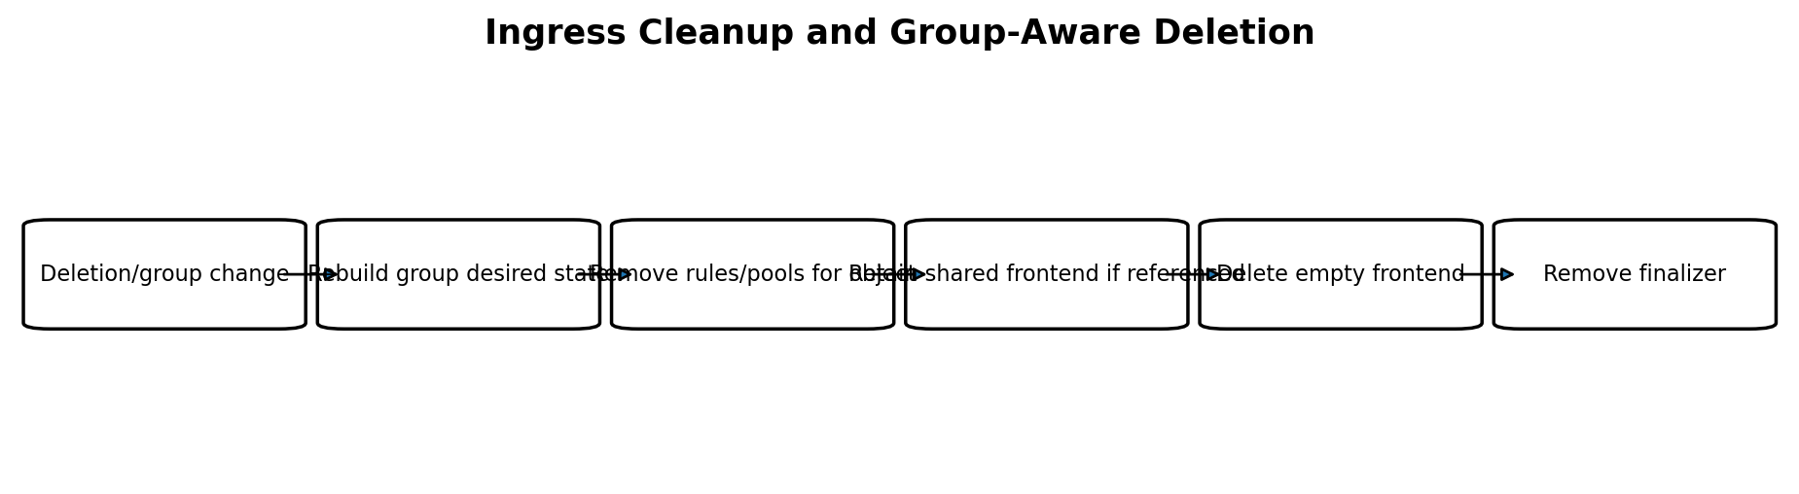
Figure 4-9. Group-aware deletion and finalizer handling.

4.16.1 Finalizer Scope
Each managed Ingress receives a finalizer after acceptance and before provider resources attributable to it are created. The group frontend is not represented by one arbitrary member; ownership metadata uses the group key and source index to determine which resources remain referenced.

4.16.2 Deleting One Member
- Observe deletion timestamp and keep finalizer.
- List remaining accepted group members, excluding the deleting object from desired contributions.
- Build the reduced complete group stack.
- Deploy the reduced stack: remove obsolete rules, pools and certificates only when unreferenced.
- Verify that no provider resource still requires the deleting Ingress contribution.
- Remove the deleting Ingress finalizer.

4.16.3 Deleting the Last Member
- Desired group becomes empty.
- Delete routing rules and default actions.
- Delete pools, members, monitors and certificates.
- Delete Virtual Servers.
- Delete VIP when group-owned.
- Delete LB Service.
- Confirm absence and remove finalizer.

4.17 Unsupported and Deferred Cases
Case | Initial behavior | Reason / future path
Resource backend instead of Service backend | Reject | CMP mapping not defined.
Cross-namespace Service or Secret | Reject | Requires explicit authorization/reference-grant design.
ImplementationSpecific pathType | Reject by default | Avoid provider-dependent hidden semantics.
Regex paths | Reject | Not part of standard Ingress path semantics and unsafe to approximate.
Weighted multi-backend action | Reject/defer | Standard Ingress has one backend per path; may be future annotation/CRD feature.
Request-header rewrite, URL rewrite | Defer unless typed feature is designed | Requires explicit capability and validation model.
Client certificate/mTLS | Defer | Needs certificate-authority and policy lifecycle design.
TCP/UDP listeners | Reject | Ingress is HTTP(S); use Service LoadBalancer or future dedicated API.
Multiple incompatible default backends in group | Reject group | Ambiguous fallback.
Conflicting shared listener annotations | Reject group | Cannot safely choose one member.
Certificate not covering TLS host | Reject or warn by strictness policy | Avoid serving an incorrect identity.
More rules/certs/members than CMP limit | Reject with quota condition | Prevent partial programming.

No silent degradation
Unsupported behavior must produce a precise validation result. The controller must not ignore a requested field and still report the Ingress as fully programmed.

4.18 Sequence Diagrams
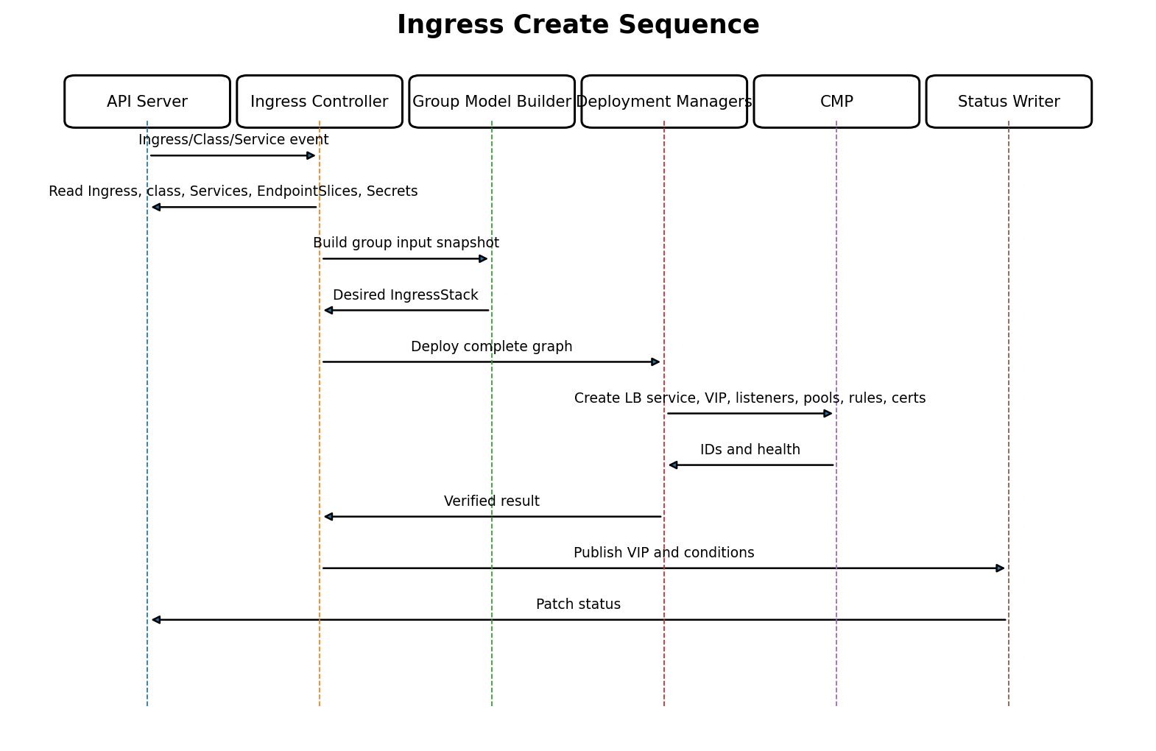
Figure 4-10. Ingress creation and initial programming.
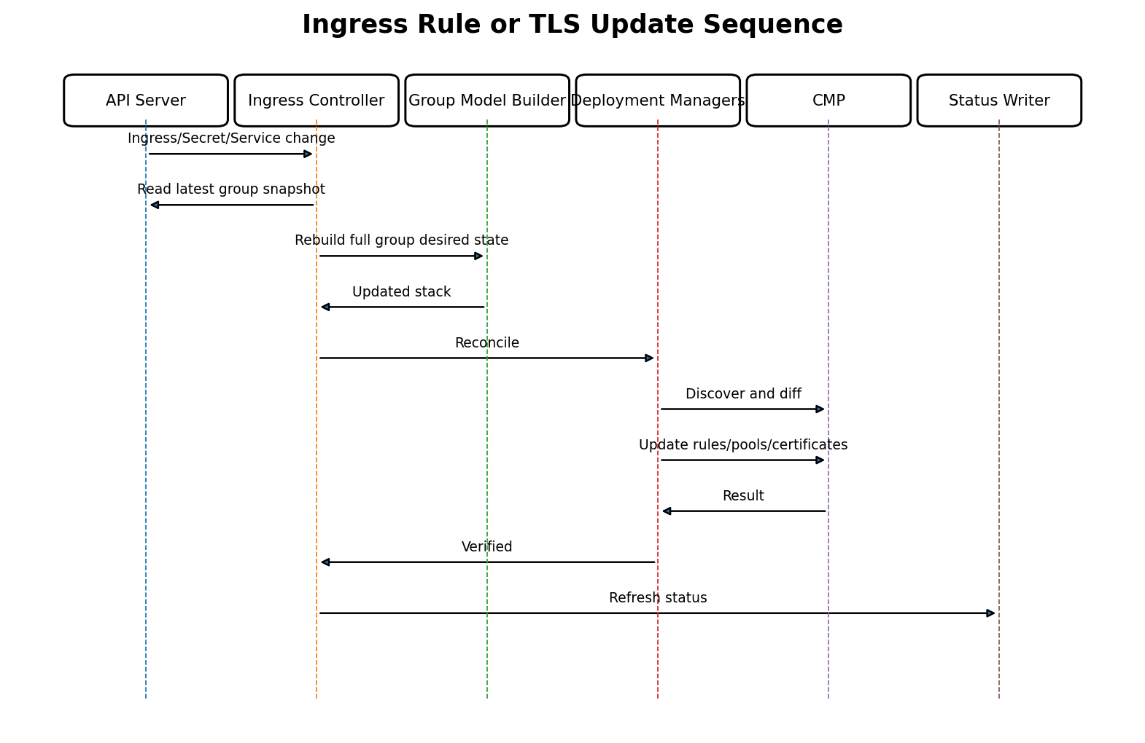
Figure 4-11. Rule, backend or TLS update.
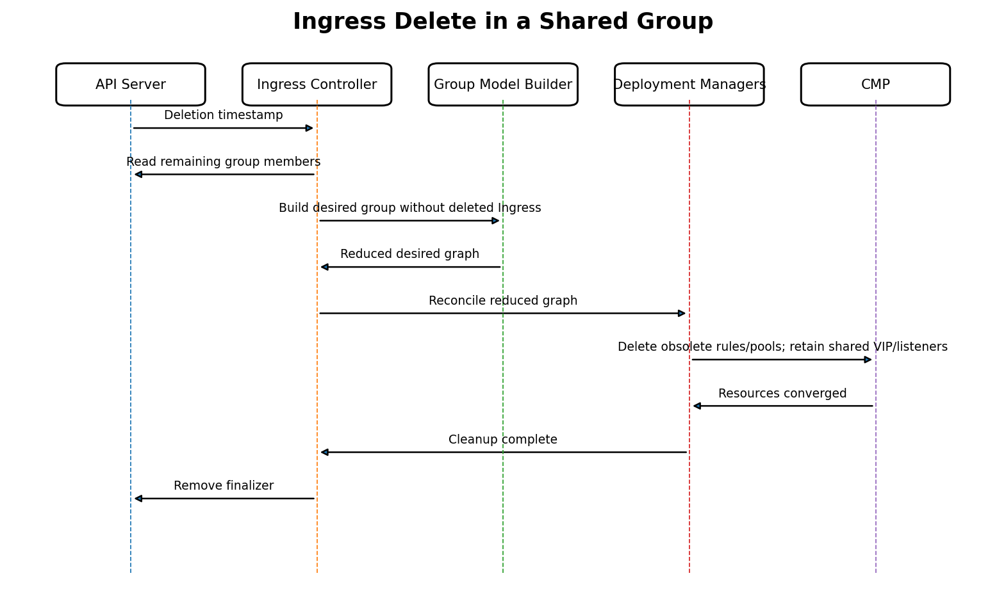
Figure 4-12. Deleting one Ingress from a shared group.

4.18.1 Scale and Node Replacement
EndpointSlice and Node changes enqueue every group whose referenced Services are affected. The model builder reuses stable pool logical IDs and changes only member models. The deployment layer therefore updates pool membership while preserving rules, listeners, VIP and LB Service.

4.19 Design Decisions
Decision | Rationale
LB Service is mandatory for Ingress | CMP defines it as the top-level lifecycle and ownership boundary; Ingress does not create a parallel hierarchy.
Reconcile one complete group stack | Avoids independent controllers racing to mutate shared listeners and rules.
Explicit grouping only | Prevents accidental cross-team sharing and unclear ownership.
One pool per unique Service+port+policy | Allows multiple routes to reuse backend state and avoids route-driven pool churn.
Stable semantic rule priority | Preserves Kubernetes routing semantics independent of event/list order.
Reject ImplementationSpecific by default | Avoids undocumented provider semantics.
TLS Secret material handled only in certificate layer | Reduces exposure and keeps controllers/model logs free of secrets.
NodePort backend mode reused from Service design | Matches CMP backend_port_id integration and avoids direct Pod-network dependency.
Last-known-good on invalid update | Avoids outages caused by temporary invalid references or certificates.
Ownership metadata on every resource | Enables restart recovery, safe deletion and conflict detection.
Status only after verification | Prevents a VIP from being presented as usable before complete programming.

4.19.1 Proposed Package Boundaries
pkg/ingress/controller
pkg/ingress/classresolver
pkg/ingress/groupresolver
pkg/ingress/validator
pkg/ingress/modelbuilder
pkg/ingress/routing
pkg/ingress/certificates
pkg/ingress/status
pkg/backendresolver // shared with Service design
pkg/model // IngressStack and resource models
pkg/deploy // stack deployer and resource managers
pkg/cmpclient // typed CMP clients
pkg/ownership

4.19.2 Core Interfaces
type ClassResolver interface {
Resolve(ctx context.Context, ingress *networkingv1.Ingress) (ResolvedClass, Decision, error)
}
type GroupResolver interface {
ResolveKey(ingress *networkingv1.Ingress, class ResolvedClass) GroupKey
ListMembers(ctx context.Context, key GroupKey) ([]networkingv1.Ingress, error)
}
type IngressGroupValidator interface {
Validate(ctx context.Context, input GroupBuildInput) ValidationResult
}
type IngressModelBuilder interface {
Build(ctx context.Context, input GroupBuildInput) (*model.IngressStack, error)
}
type IngressStackDeployer interface {
Deploy(ctx context.Context, desired *model.IngressStack) (DeploymentResult, error)
Delete(ctx context.Context, owner ownership.GroupOwner) error
}

4.20 Summary and Implementation Checklist
The Ingress controller translates standard Kubernetes HTTP(S) routing intent into one CMP/F5 graph rooted at an LB Service. Class handling and group resolution occur before model construction. The model builder produces deterministic listeners, certificates, rules and pools. Deployment managers converge the graph in dependency order and status is published only after verification.
Area | Implementation check
Class | Stable controller identifier; default-class policy; parameter validation.
Watches | Ingress, IngressClass, Service, EndpointSlice, Secret and Node indexes.
Grouping | Explicit group key; namespace security boundary; complete group reconciliation.
Validation | Static webhook plus authoritative runtime validation.
Routing | Exact/Prefix semantics; wildcard-host rules; deterministic priority.
Default backend | Single effective fallback and conflict handling.
TLS | Secret parsing, key match, host coverage, de-duplication and rotation.
Backends | ServicePort resolution and shared Node->VM->backend_port_id resolver.
Model | LB Service, VIP, listeners, rules, pools, members, monitors and certificates.
Deployment | Ownership discovery, minimal diff, dependency order and verification.
Status | VIP, Accepted, ResolvedRefs, Programmed, Ready, Degraded and Conflict.
Recovery | Unknown-result discovery, last-known-good and controller restart convergence.
Deletion | Source index, group-aware cleanup and finalizer removal after verification.
Unsupported | Explicit rejection with precise condition/event; no silent approximation.
Tests | Unit tests for sorting/conflicts; fake-client reconciliation; CMP contract tests; restart and deletion integration tests.

Recommended Implementation Order
- IngressClass resolver and eligibility.
- Reference indexes and event mapping.
- Single-Ingress, single-host HTTP model builder.
- Backend Service/port and pool reuse.
- Exact and Prefix routing priority.
- Default backend.
- TLS Secret and certificate manager.
- Explicit same-namespace grouping.
- Status and conditions.
- Group-aware finalization and last-member cleanup.
- Capability/limit validation and advanced recovery tests.
Completion criterion
Part 4 is implementation-ready when the same immutable group input always produces the same logical graph, deployment managers can converge that graph from empty or partially observed CMP state, and deletion can prove that only owned, unreferenced resources are removed.

